**Assignment -4 Kubernetes / Docker**

|  |  |
| --- | --- |
| Student Name | DEEPIKALA V |
| Student Roll Number | 621319104011 |
| Maximum Marks | 2 Marks |

**Question-1:**

Pull an Image from docker hub and run it in docker playground.

Solution:

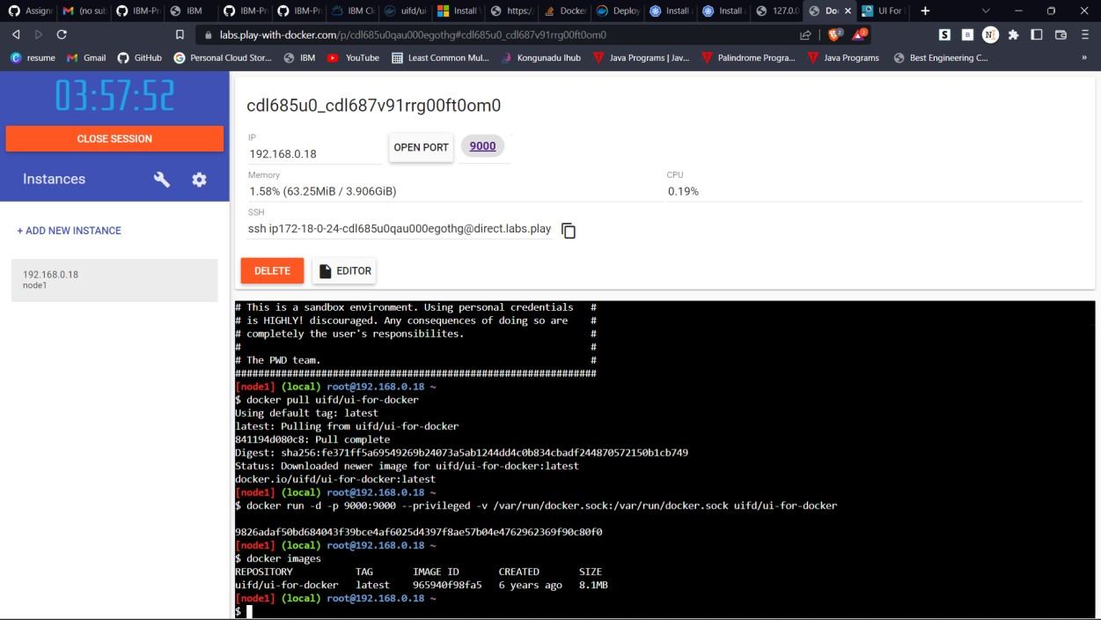

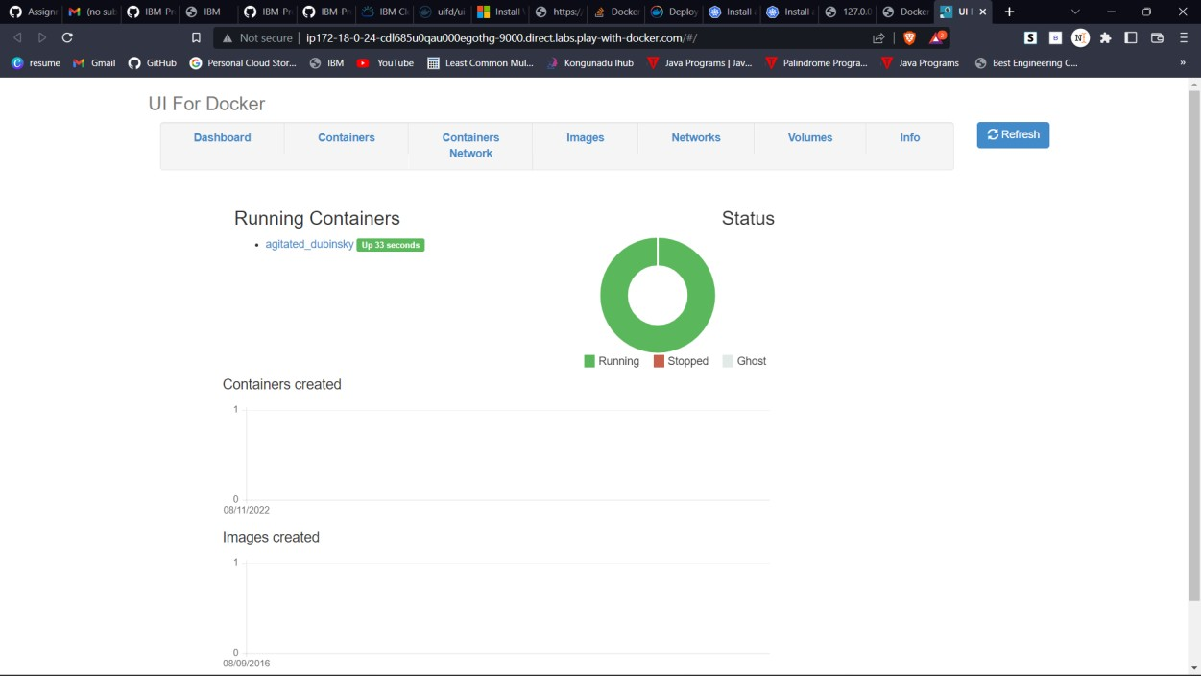

**Question-2:**

Create a docker file for the nutrition application and deploy it in Docker desktop application.

# Solution:

**app.py**

from flask import *

app = Flask( name )

@app.route("/")

def home():

return "Hello World"

if name == " main ":

app.run(debug=True)

# Dockerfile:

FROM python:3.6 WORKDIR /app ADD . /app

COPY requirements.txt /app

RUN python3 -m pip install -r requirements.txt RUN python3 -m pip install ibm_db

EXPOSE 5000

CMD ["python","app.py"]

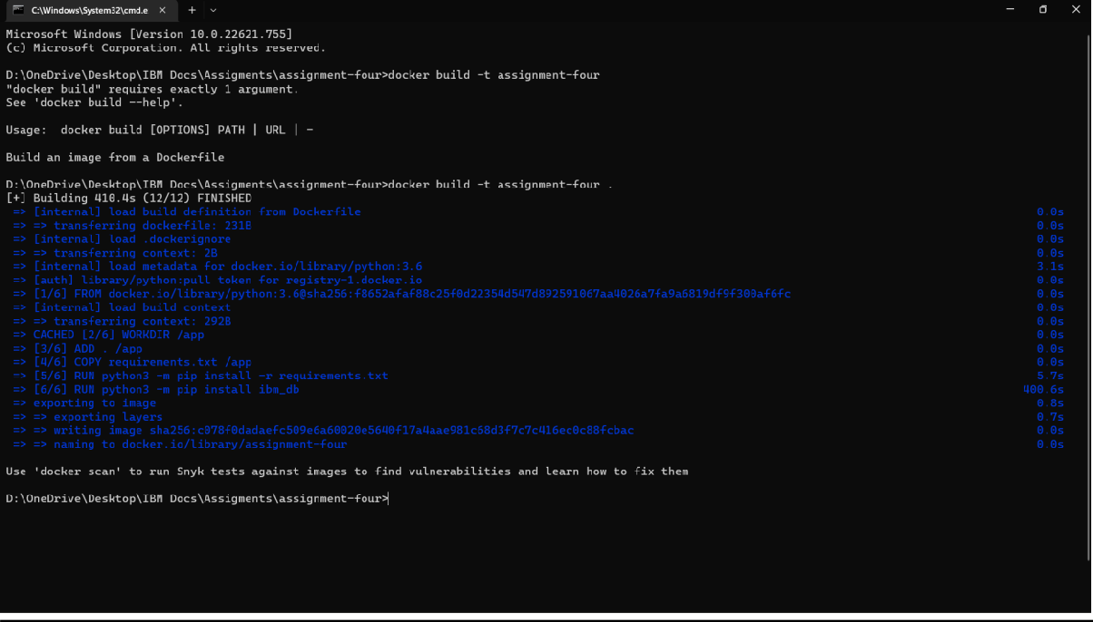

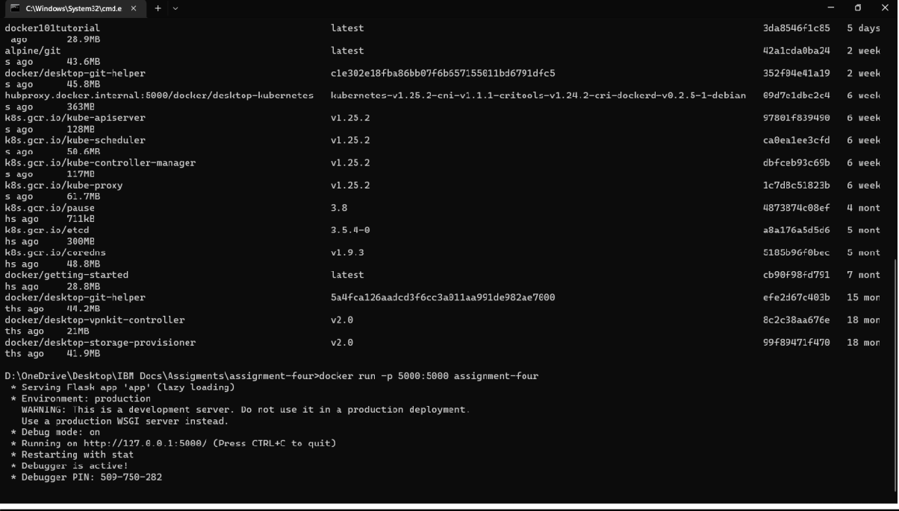

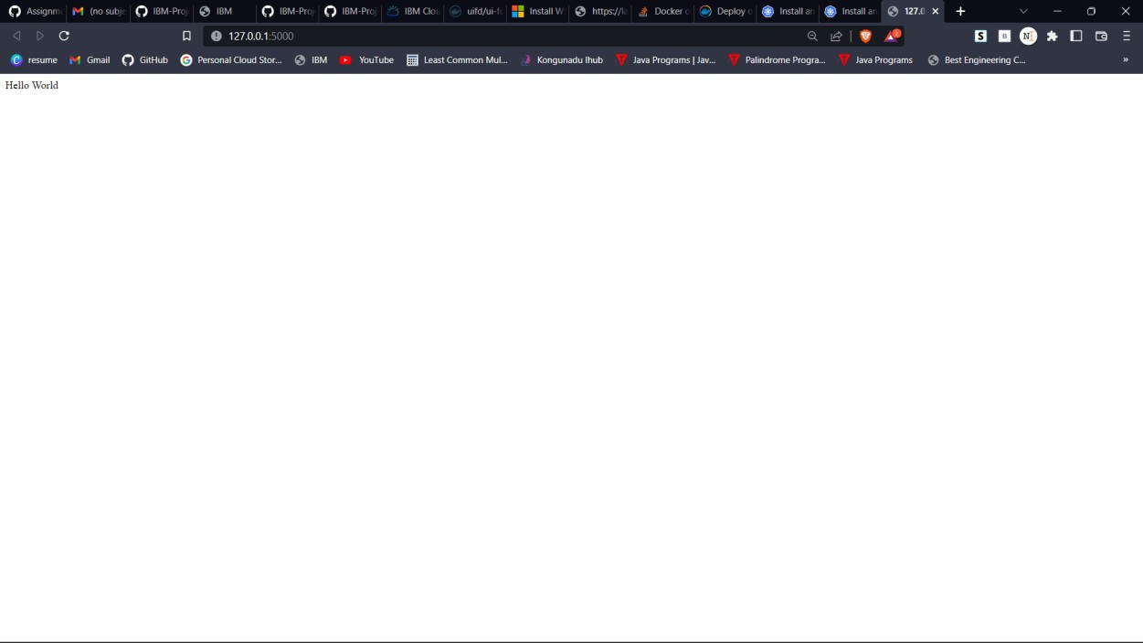

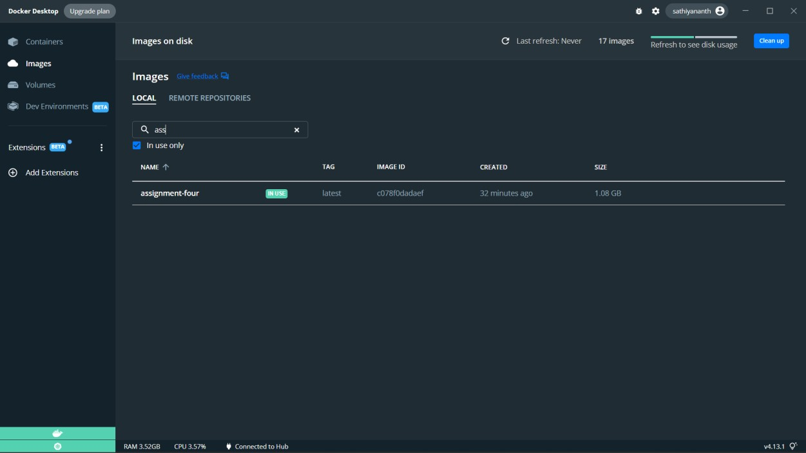

**Question-3:**

Create a IBM container registry and deploy helloworld app or nutrition app.

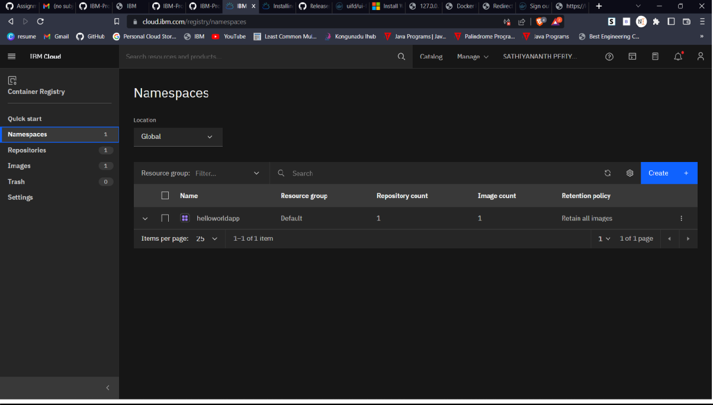

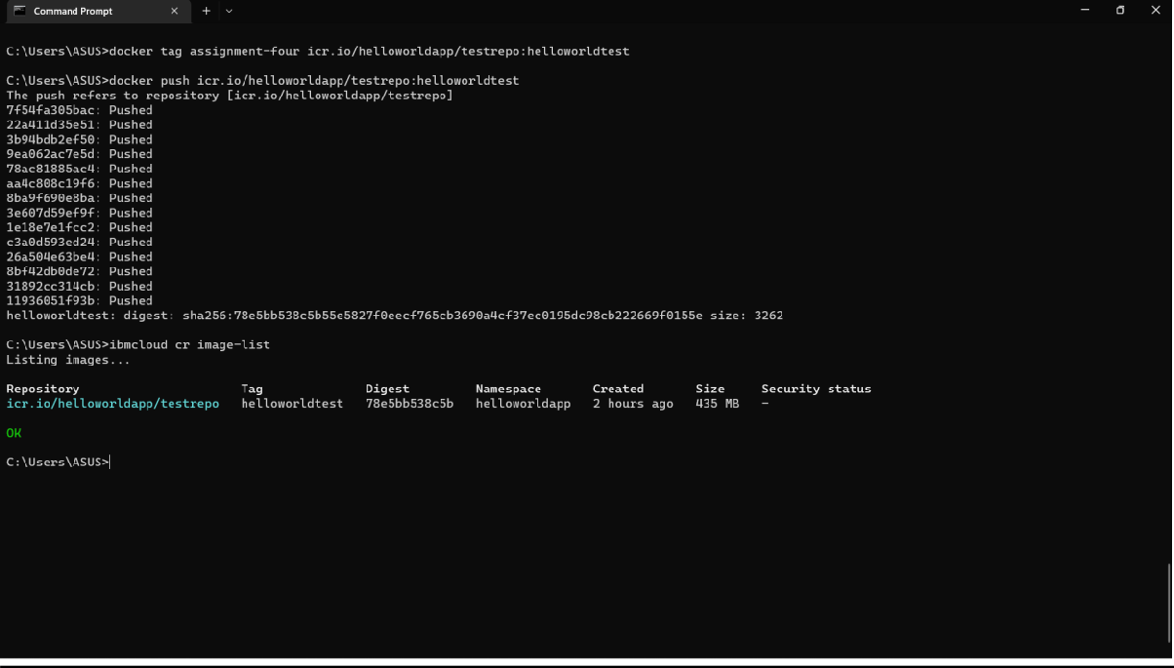

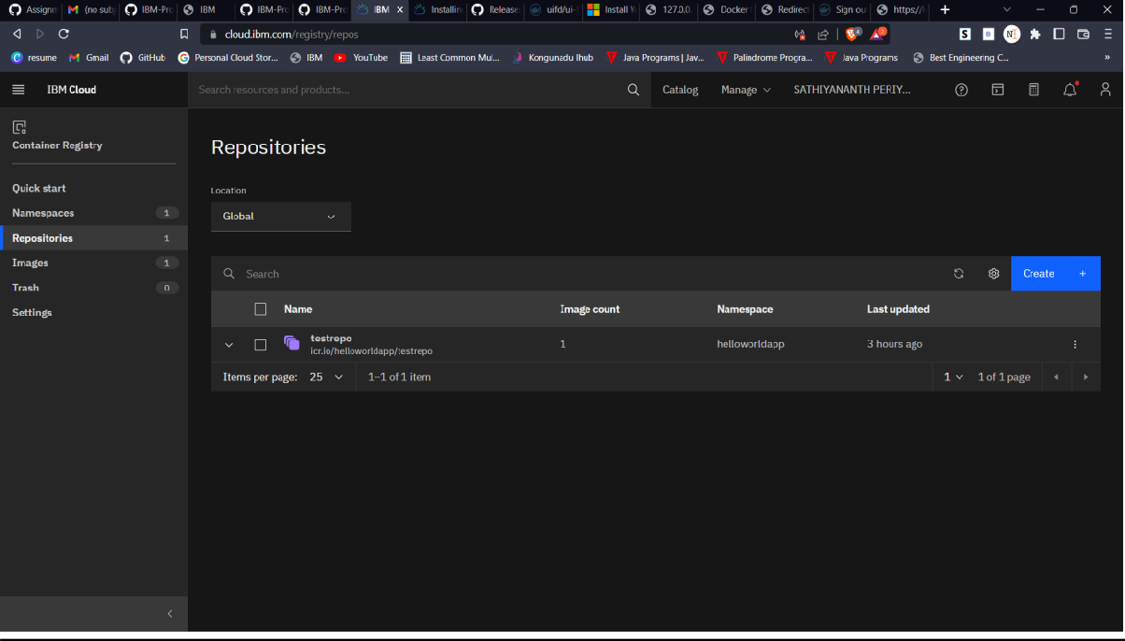

**Question-4:**

Create a Kubernetes cluster in IBM cloud and deploy helloworld image or nutrition image and also expose the same app to run in node port.

